**Software Requirement Specification**

**INTRODUCTION**

As now most of the things are being available on the internet swiftly but to be more precise the quality of the information and practical knowledge also matters. Clear and complete definition of everything is far most mandatory to comprehend. A web design learning platform is the work that happens behind the scenes to make a website look great, work fast, provide relevant information and perform well with a seamless user experience. Now-a-days, humongous learning websites are available that provides different relevant information in connection with the different searched topics, but the content also matters. The website that we are proposing will be designed for better interaction between different users and will also provide a platform to make available all essential web development books and appropriate pertinent videos. Users can search their record according to essential and relevant requirements. Giving access to the required information plays a vital role along with the recommendations. All the searches will consists of highly recommended books as per users apposite requirements. User related queries will be resolved swiftly.

**MANAGEMENT SUMMARY**

Web development refers to building, creating, and maintaining websites. It includes aspects such as web design, web publishing, web programming, and database management, These tools make it easy for anyone to create and edit their own website using a web-based interface. Web development skills are in high demand worldwide and well paid too – making development a great career option. It is one of the easiest accessible higher paid fields as you do not need a traditional university degree to become qualified. The field of web development is generally broken down into front-end (the user-facing side) and back-end (the server side). This project will provide a platform to make available all essential web development books. Also, it will provide different front-end and back-end courses with appropriate relevant videos. This website will permit user to view and download pertinent books.

**KEY ASSUMPTIONS**

1. User can easily log in to the website

2. All the user sessions will be saved in the database.

3. Provide a platform to make available all essential web development books.

4. Provide different front-end and back-end courses with appropriate relevant videos

5. This website will permit user to view and download pertinent books.

6. This website provides a feature for user to search their relevant choice based books.

7. To interact with user related queries.

8. Recommended books will be displayed.

9. The system should present the information to the user clearly and precisely.

10. Content based filtering method analyzes and selects various user recommendations.

**HIGH LEVEL ARCHITECTURE**

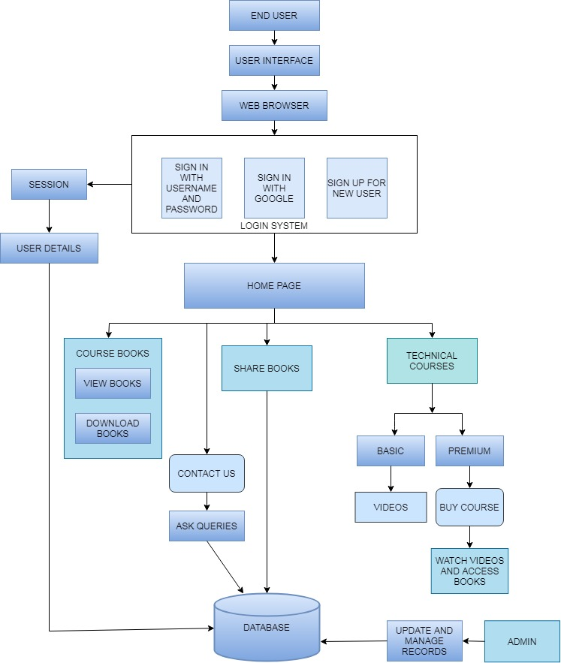

The above diagram depicts the overall architecture of the system. End User through a web browser can sign in / sign up. The login system contains 3 alternatives for which the registration is to be performed. It includes sign in with username and password, sign in with Google, sign up for new user. The Home page consists of different pages. Course books page permits user to view and download books. User also can share good content books. The technical courses consists of Basic and Premium courses. The basic course contains videos whereas premium includes buying course with an access to all the videos and books. All the user sessions and details of entire system will be saved in the database. Admin can update, record and manage the further progress.

**FUNCTIONAL REQUIREMENTS**

The high level functional requirements for our project is outlined well in the Use Case Diagram. The Product is a web-based learning product, which will be used by multiple users i.e. the software developers, college students, registered user and guest. An administrator will be provided with the Interface, with the help of which the administrator can manage accounts and UI. Registered users can edit their information using their login credentials. Customers can generate the cart according to his requirement. Users can search their record according to essential and relevant requirements.

The "Web design learning platform" is an independent web-based website. There are various user interfaces related to this software. These interfaces help the user to interact with it and provide the necessary information for online books.

The entire functionality of this can be subdivided into fields/modules. The names of the fields involved in the web development platform are:-

• Sign up Page: This is the page if the user is new the he/she can successful sign up and create an account by filling up all the details.

• Book Description: If the user would like to know details about a book he can click on the link from where he will be directed to a Book description page.

• Managing User Accounts: Each user should have an account to access all the functionalities of the website. Users can sign in using the login page and sign out using the logout page. All the user sessions will be saved in the database.

• Administration: The Administrator will be provided with special functionalities like Add or delete a book category, resolve users queries and manage the database.

 The system should provide only authorized access to critical data. The system should check data integrity for critical variables. All fields should be validated before data is sent to the database. Users will be able to access only their personal information and not that of other users. Purchases will be handled through a secure server to ensure the protection of the user's credit card and personal information.

**USE CASE DIAGRAM**

The following figure illustrate the Use Case Diagram for the system.

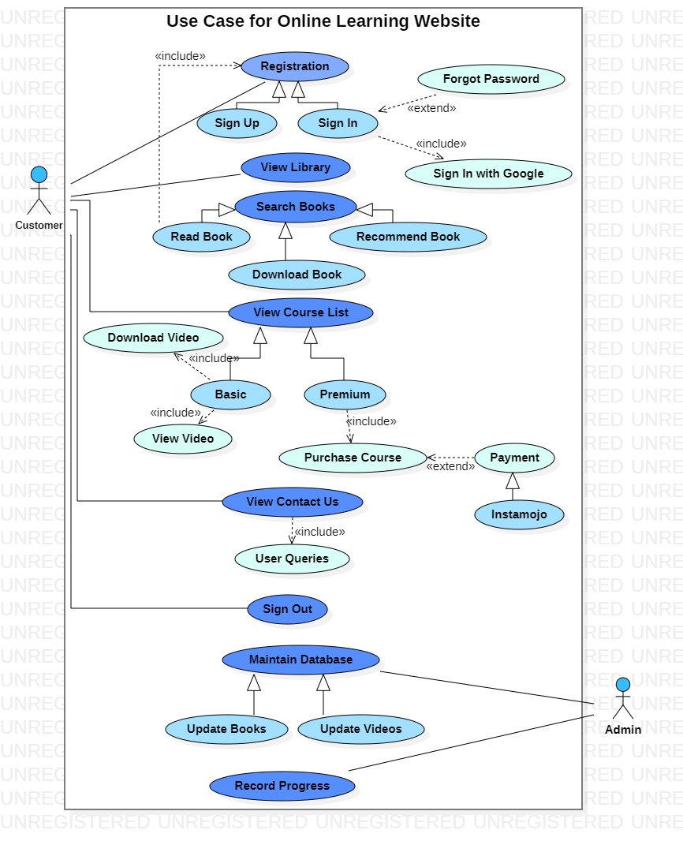

The above use case diagram includes several use cases performing different operations which includes:

* Registration can be performed through sign in with Google alternative.
* User can look up for their relevant choice based books
* Users can view, download and share books
* Premium course requires purchasing the course and payment can be done through Instamojo.
* Contact us page allows users to accept their queries which will be solved by the admin
* Admins are required to maintain and update database along with recording progress.

Database Design Guidelines

The "Web development learning platform " is an independent web-based website. There are various user interfaces related to this software. These interfaces help the user to interact with it and provide the necessary information for online books. The field of web development is generally broken down into front-end (the user-facing side) and back-end (the server side).

The language requirements are HTML, Bootstrap, Materialize CSS, CSS, JavaScript, PHP, MySql, XAMP. The front-end consists of Bootstrap, CSS, Materialize CSS. The back end consists of Mysql and php

Following checklist plays a vital role for database design:

1. Users of the system will be provided with the Graphical user interface, there is no Command-line interface for any function.The user interface provided by the system are user-friendly.

2. High scores in Software Quality Attributes enable software architects to guarantee that a software application will perform as the specifications provided by the client. Every software-driven system is designed for ease of use to accomplish certain tasks.

3. This project will provide a platform to make available all essential web development books. Also, it will provide different front-end and back-end courses with appropriate relevant videos.

4. All the user sessions will be saved in the database.

5. Content based filtering method analyzes and selects various user recommendations.

6.Efficient Accessibility can lead user to choose various courses.

7.Logical and user friendly interface helps user to access the system effortlessly.

Logical Object Model

A high level logical object model of the system is shown below. During technical design it will be transformed into a physical model covering all system entities. Such a diagram will include their relationship and its cardinality.

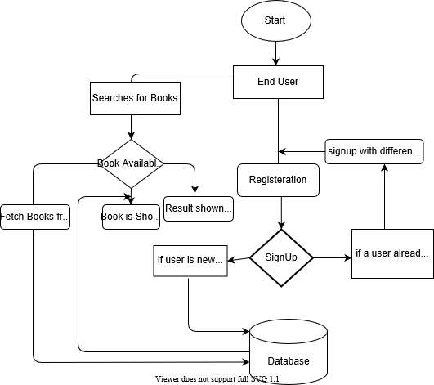

1. For registeration user has to signup
2. User with already same name or email are not allowed.
3. If user is new he has to signup first and details get stored in database
4. A high level logical object model of the system is shown below. During technical design it will be transformed into a physical model covering all system entities. Such a diagram will include their relationship and its cardinality

Testing Approach

Quality of the software can be achieved with basic hygiene and consistency followed during design and development of User Interface(UI), Navigation, Validations as per the business process requirement.

To ensure the project delivers acceptable quality to the customer, it's important to create a checklist of the conventions to be followed across. Common checks as below are for your reference during design and development:

|  |  |
| --- | --- |
| Common Checks | Validation Type |
| The website permits to downloads book | UI |
| Order of the Data Entry Fields is logical as per the functionality being provided by the feature | UI |
| Efficient Accessibility can lead user to choose various courses | Navigation |
| The website permits to view book | UI |
| Content based filtering method analyzes and selects various user recommendations. functional | Functional |
| Registered users can edit their information using their login credentials | UI |
| Data Entry field basic validations are working i.e Text field /emails allow data for their type only | Functional |
| All the user sessions will be saved in the database.  functional | Functional |
| The color scheme of all forms i.e headers labels , alerts, entry fields are uniform throughout the application | UI |
| The action buttons for a New Data Entry Form are uniform for all forms that is allowing data entry | UI |
| Users can search their record according to essential and relevant requirements. | Functional |
| The links provided on the forms are opening correctly | Functional |

Suggested Technical Reading

The project is aimed at creating doubt clearing groups and Comprehensible information sharing between users. The following reading reference is easy to understand and should be read to get a clear understanding of capabilities of the tools and how you would leverage them to execute a project.

**Software Process Model**

Software life cycle models describe phases of the software cycle and the order in which those phases are executed. Each phase produces deliverables required by the next phase in the life cycle.

Requirements are translated into design. Code is produced according to the design which is called development phase.

After coding and development the testing verifies the deliverable of the implementation phase against requirements. The testing team follows [**Software Testing Life Cycle (STLC)**](http://tryqa.com/what-is-software-testing-life-cycle-stlc/) which is similar to the development cycle followed by the development team.

There are following six phases in every Software development life cycle model:

1. Requirement gathering and analysis
2. Design
3. Implementation or coding
4. Testing

The first increment is often a [core product](http://en.wikipedia.org/wiki/Core_product) where the necessary requirements are addressed, and the extra features are added in the next increments. The core product is used and evaluated by the client. Once the customer assesses the core product, there is plan development for the next increment. Thus, in every increment, the needs of the client are kept in mind, and more features and functions are added, and the core product is updated. This process continues until the complete product is produced.

The first increment is often a [core product](http://en.wikipedia.org/wiki/Core_product) where the necessary requirements are addressed, and the extra features are added in the next increments

**Advantages of Incremental model:**

* Generates working software quickly and early during the software life cycle.
* This model is more flexible – less costly to change scope and requirements.
* It is easier to test and debug during a smaller iteration.
* In this model customer can respond to each built.
* Lowers initial delivery cost.
* Easier to manage risk because risky pieces are identified and handled during it’d iteration.

**Disadvantages of Incremental model:**

* Needs good planning and design.
* Needs a clear and complete definition of the whole system before it can be broken down and built incrementally.
* Total cost is higher than [**waterfall**](http://tryqa.com/what-is-waterfall-model-advantages-disadvantages-and-when-to-use-it/).

**When to use the Incremental model:**

* This model can be used when the requirements of the complete system are clearly defined and understood.
* Major requirements must be defined; however, some details can evolve with time.
* There is a need to get a product to the market early.
* A new technology is being used
* Resources with needed skill set are not available
* There are some high risk features and goals.